ReNewMarket – Second-hand Marketplace
Project: ReNewMarket | Technology: HTML, CSS, JavaScript (localStorage)

Aim
To create an online marketplace where users can sell used items, buy items, make offers and give feedback, with admin control.

Algorithm
- Start: load users, categories, items, offers and orders.
- Seller lists an item with category and price.
- Buyer browses, adds favourites, buys directly or sends an offer.
- Seller accepts or rejects the offer; accepted offer creates an order (mkOrder).
- Buyer and seller view orders and give feedback.
- Admin manages users, categories and items.
- Save data. Stop.

Result
The ReNewMarket – Second-hand Marketplace was implemented successfully using HTML, CSS and JavaScript. All modules (login, role-based pages, data entry, search/booking and admin management) work correctly in the browser, and data persists using localStorage.

Implementation (Output Screenshots)
Home page
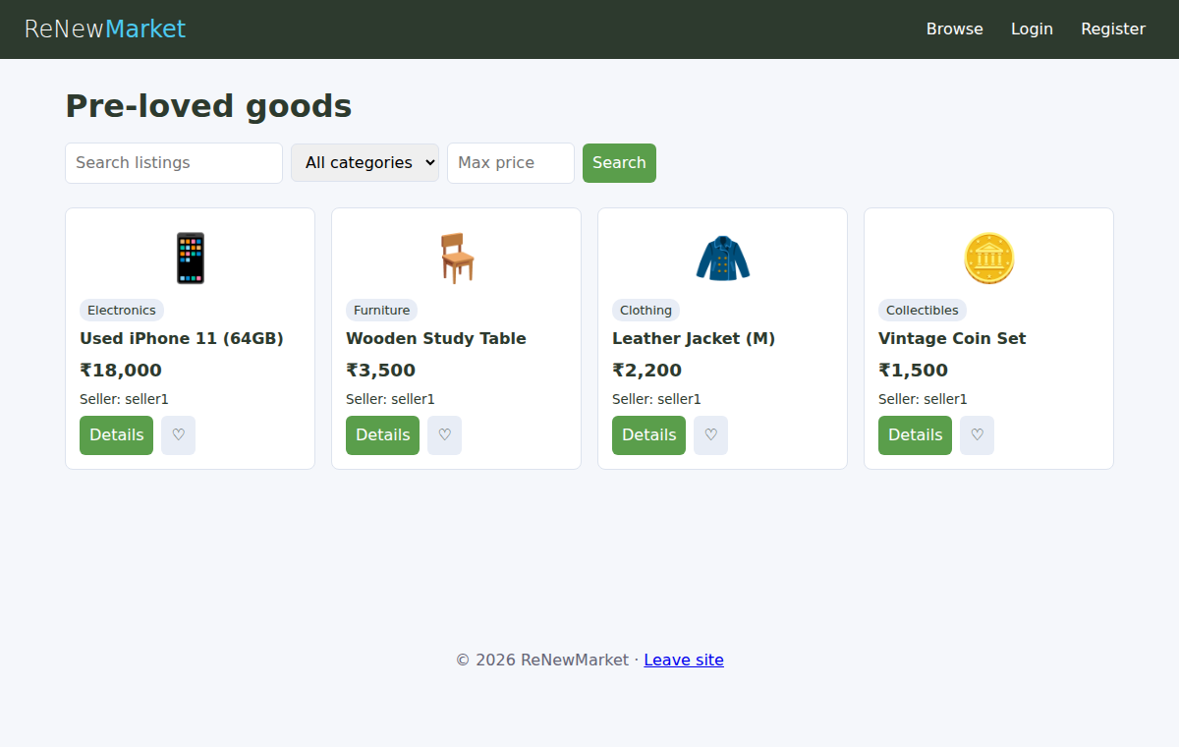
After login (admin / dashboard)
